Task: Setting Up a Multi-Server Java Application Build, Artifact Storage, and Deployment Pipeline Using Maven, Nexus, and Tomcat
Objective
The objective of this task is to set up a multi-server environment for building, storing and deploying a Java web application. The setup uses three separate servers: a Build Server to compile the Java Web Calculator application using Maven, a Nexus Repository Server to store the generated WAR artifact and a Deploy Server to download and deploy the artifact on Apache Tomcat.
Source Code
GitHub repository used for this task: Java Web Calculator App, as specified in the task requirements.
Architecture
GitHub → Build Server → Nexus → Deploy Server → Browser
The implementation uses three Ubuntu-based AWS EC2 instances, with each server assigned a separate responsibility in the deployment pipeline. This separation is required by the task to simulate a real multi-server build, repository, and deployment workflow.
Step-1: Build Server Setup (Build-VM)
- Launch Ec2 instance on AWS
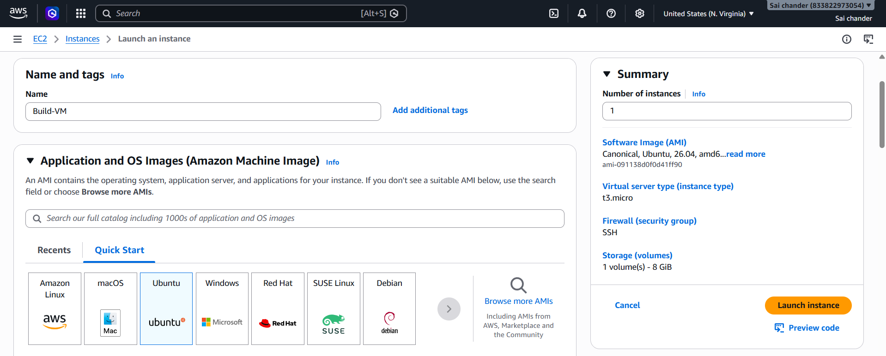
- Name instance as Build-VM
- Select ubuntu AMI
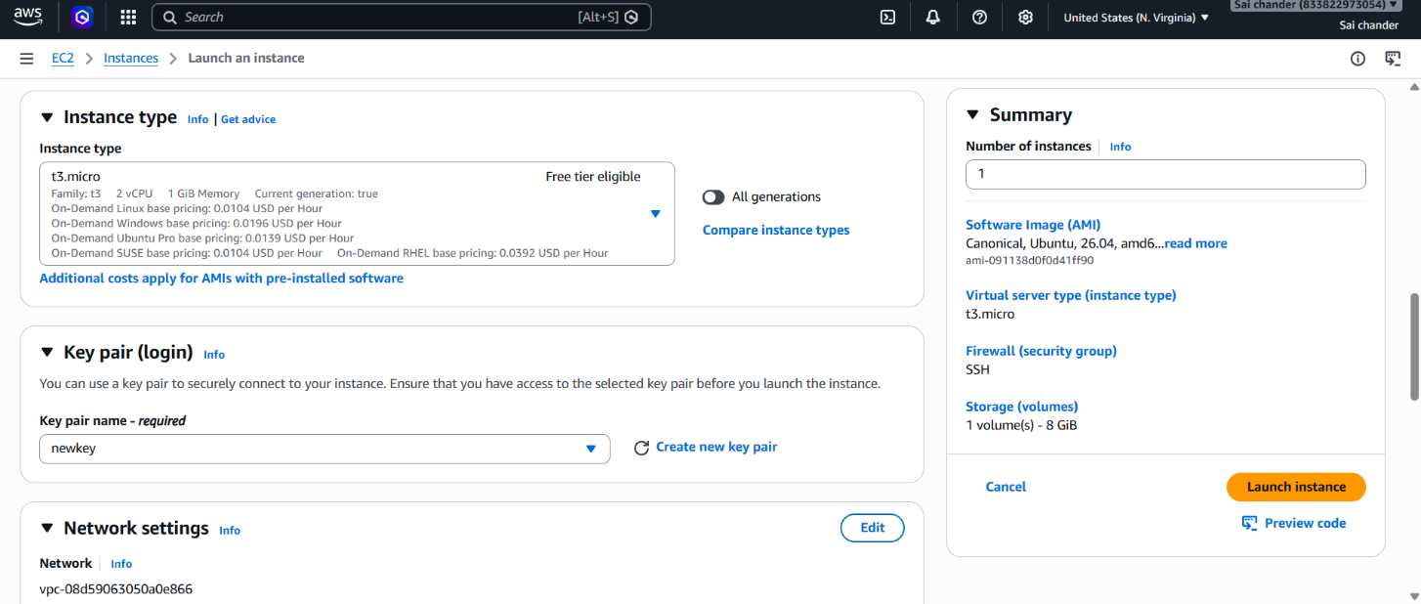
- Select Instance type t3.micro with 2vCPU and 1GB memory, keypair with SSH port 22
- Launch Instance
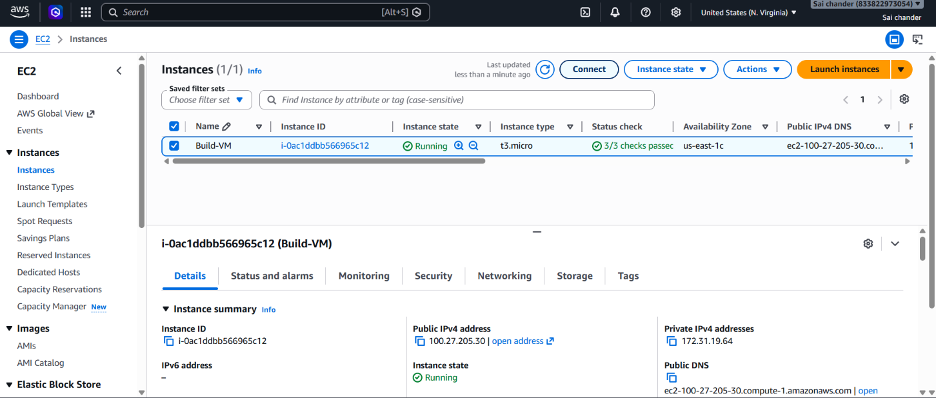
- Instance Running

- Connected to terminal via SSH client
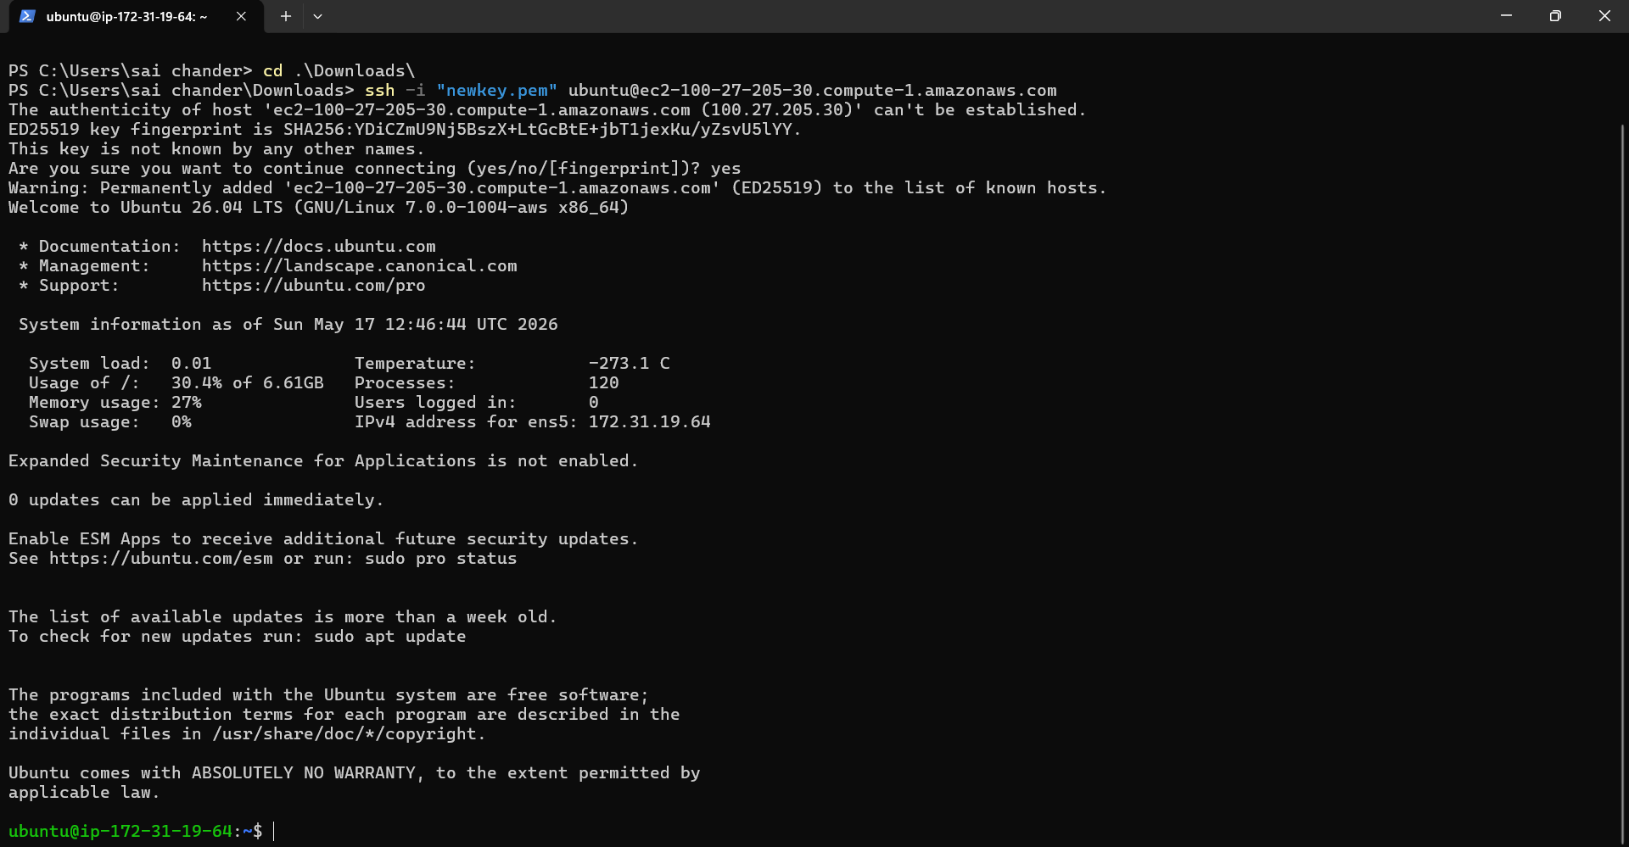
- Check if Git is installed, if not install git
sudo apt install git -y
- clone code from GitHub repository
git clone https://github.com/mrtechreddy/Java-Web-Calculator-App.git
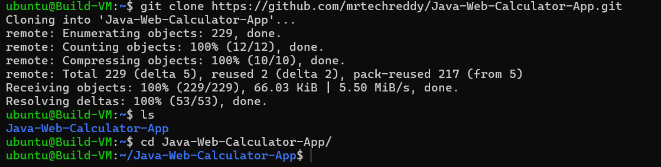
- Install Java 17
sudo apt install openjdk-17-jdk -y
sudo apt install maven -y
- Check if Java and Maven are installed
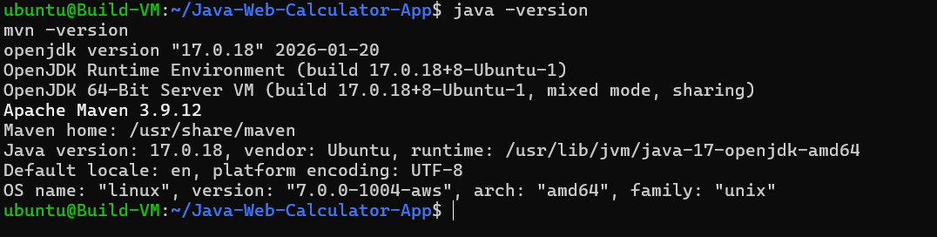
- Build project with maven
mvn clean package
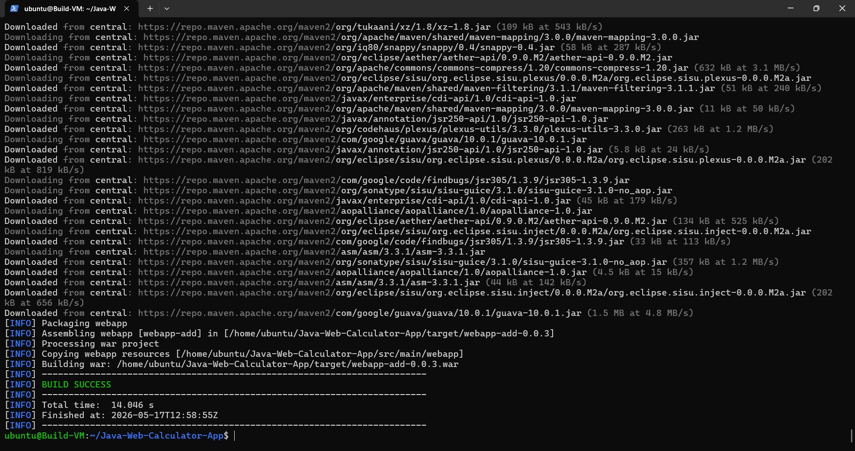
- Build Success
- WAR file generated in target directory

Step-2: Nexus Server Setup (Nexus-VM)
- Launch Ec2 instance on AWS
- Name instance as Nexus-VM
- Select ubuntu AMI
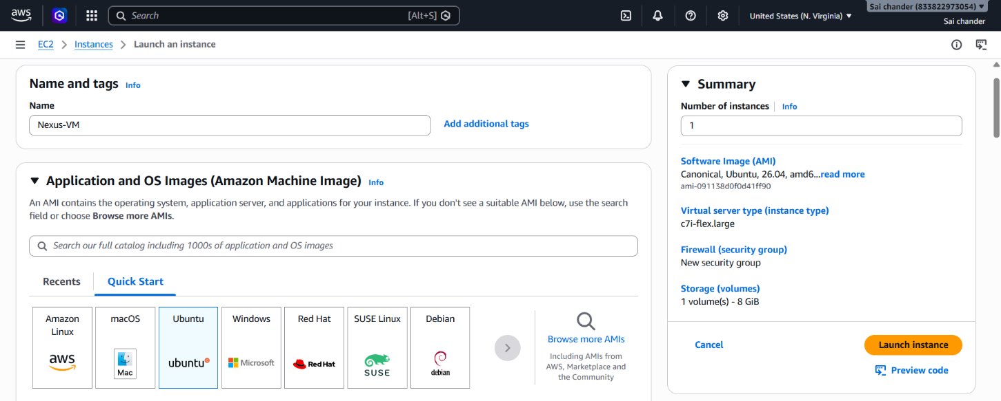
- Select Instance type c7i-flex.large with 2vCPU and 4GB memory, keypair

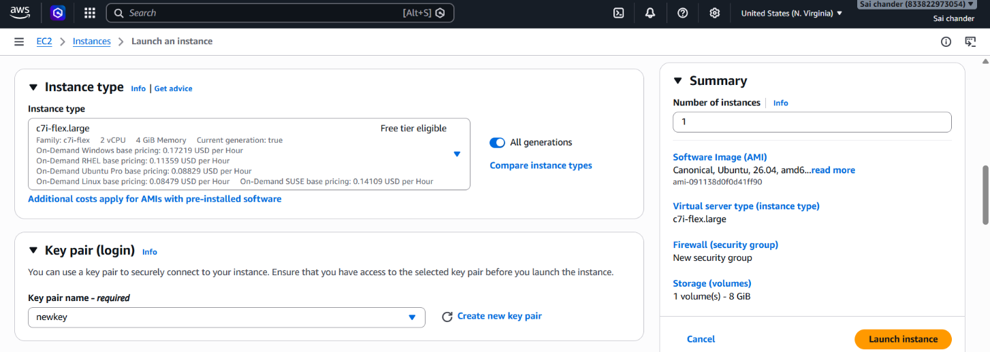
- Security Group rules - SSH port 22 and port 8081(Nexus)
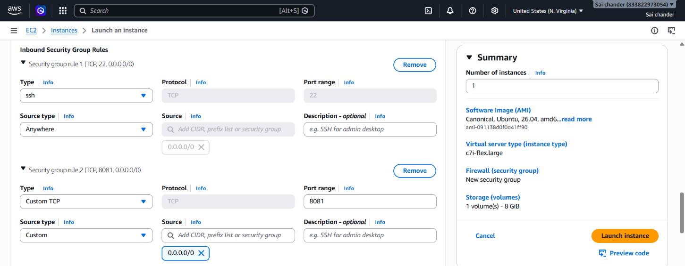
- Launch Instance
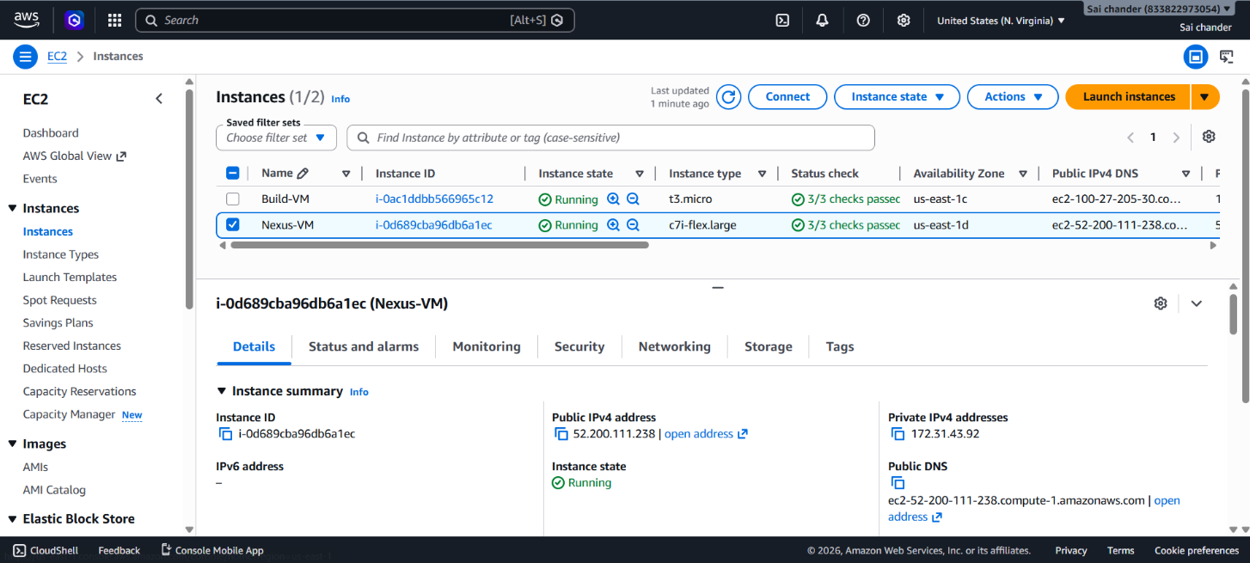
- Instance Running and connected to terminal via SSH client
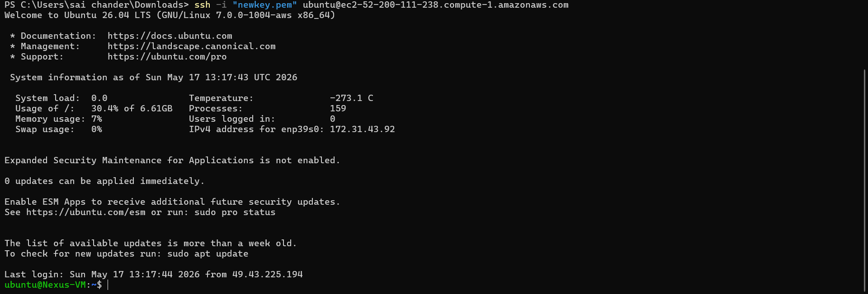
- Install Java 17
sudo apt install openjdk-17-jdk -y
- check java version
java -version
- Download and Extract Nexus
wget https://download.sonatype.com/nexus/3/nexus-3.85.0-03-linux-x86_64.tar.gz
tar -xvzf nexus-3.85.0-03-linux-x86_64.tar.gz
- Start Nexus
cd nexus-3/bin
./nexus start
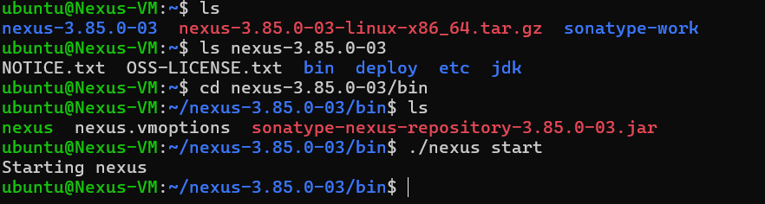
- Nexus started, verify on browser with http://<nexus-ip>:8081
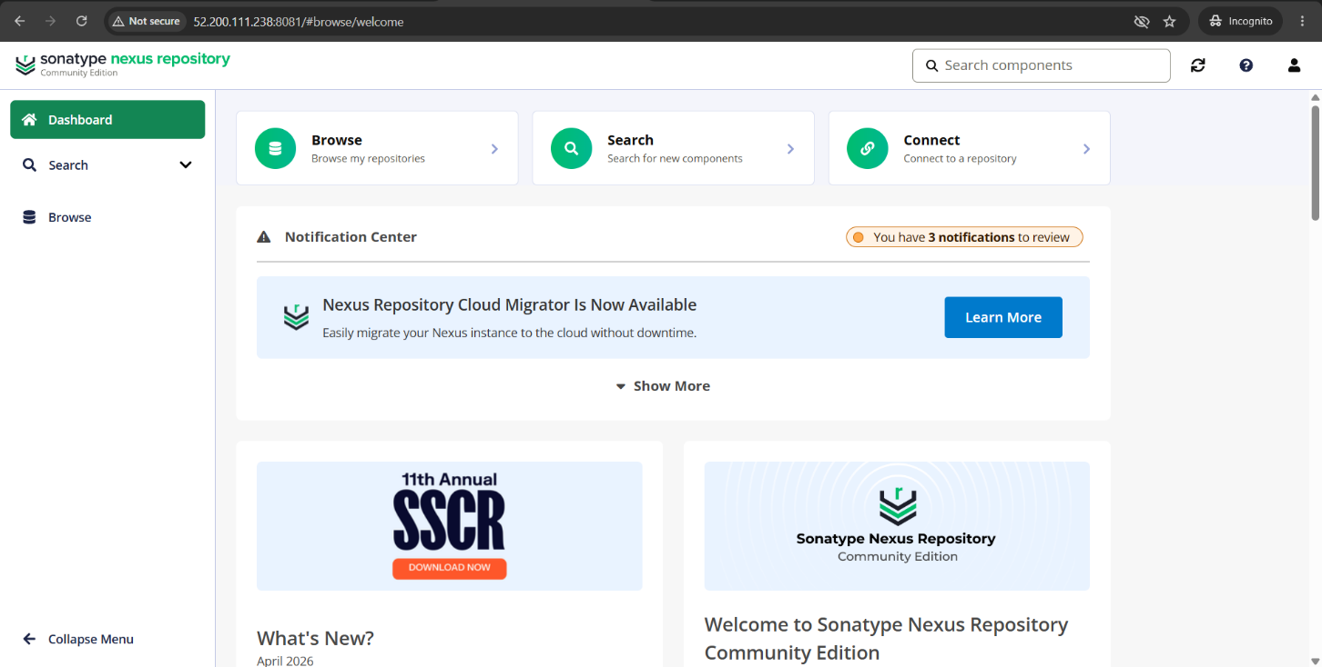
- Nexus is Running on Browser
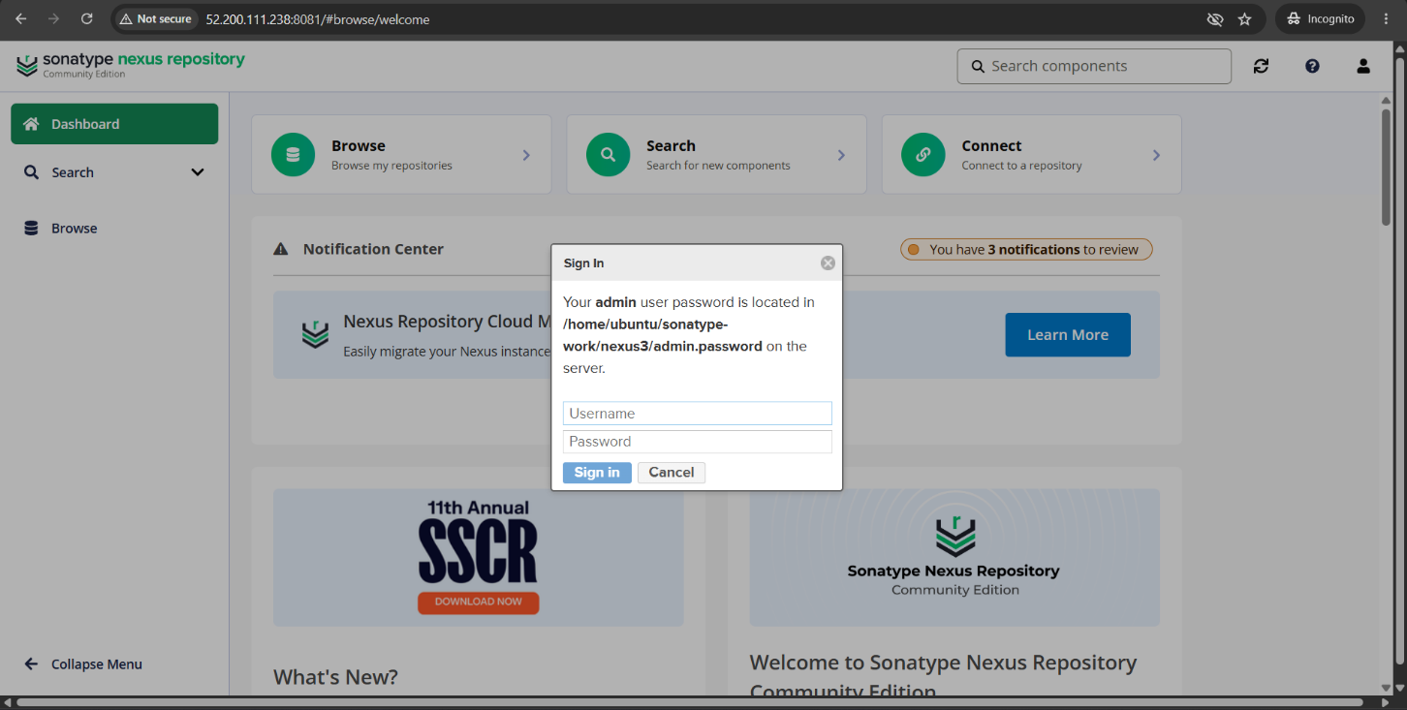
- Nexus Login page
- Retrieve Nexus password at /home/ubuntu/sonatype-work/nexus3/admin.password
- Login Nexus with Username and Password, then change password.
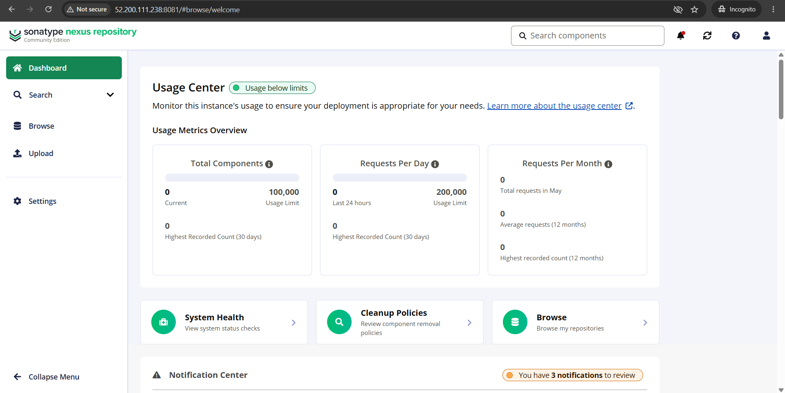
- Nexus dashboard after Login
- Copy maven-releases repository url in Nexus
Step-3: Update pom.xml and settings.xml files on Build-VM
- In pom.xml inside Project update id and maven-releases repository url
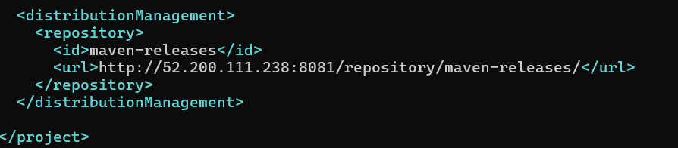
- Update settings.xml in /etc/maven/settings.xml with nexus repository id, username and password
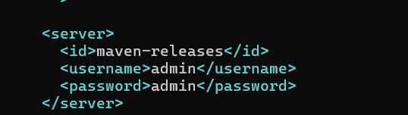
Step-4: Deploy Artifact to Nexus
mvn clean deploy
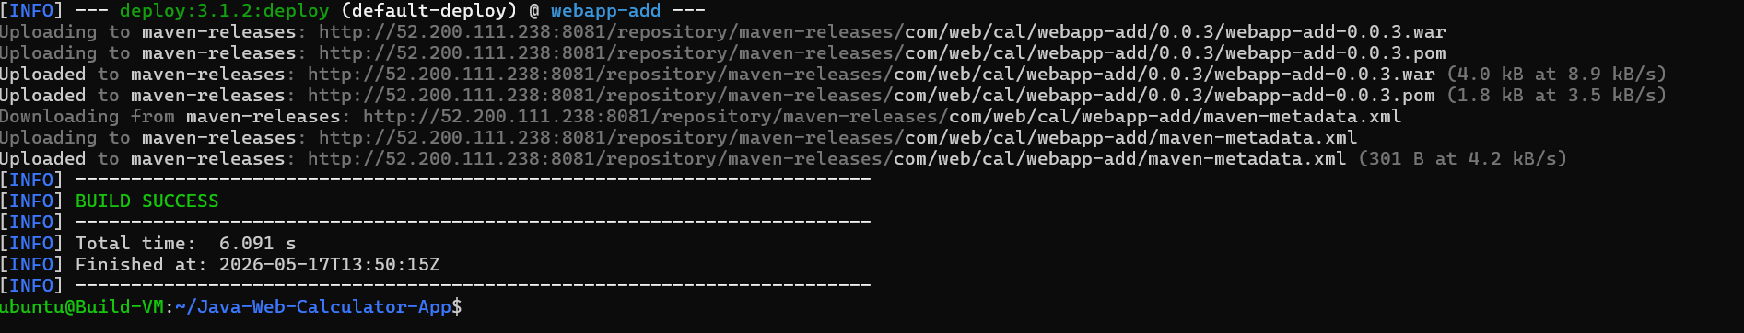
- Artifact Deployed to Nexus Repository
- Verify in maven-releases repository
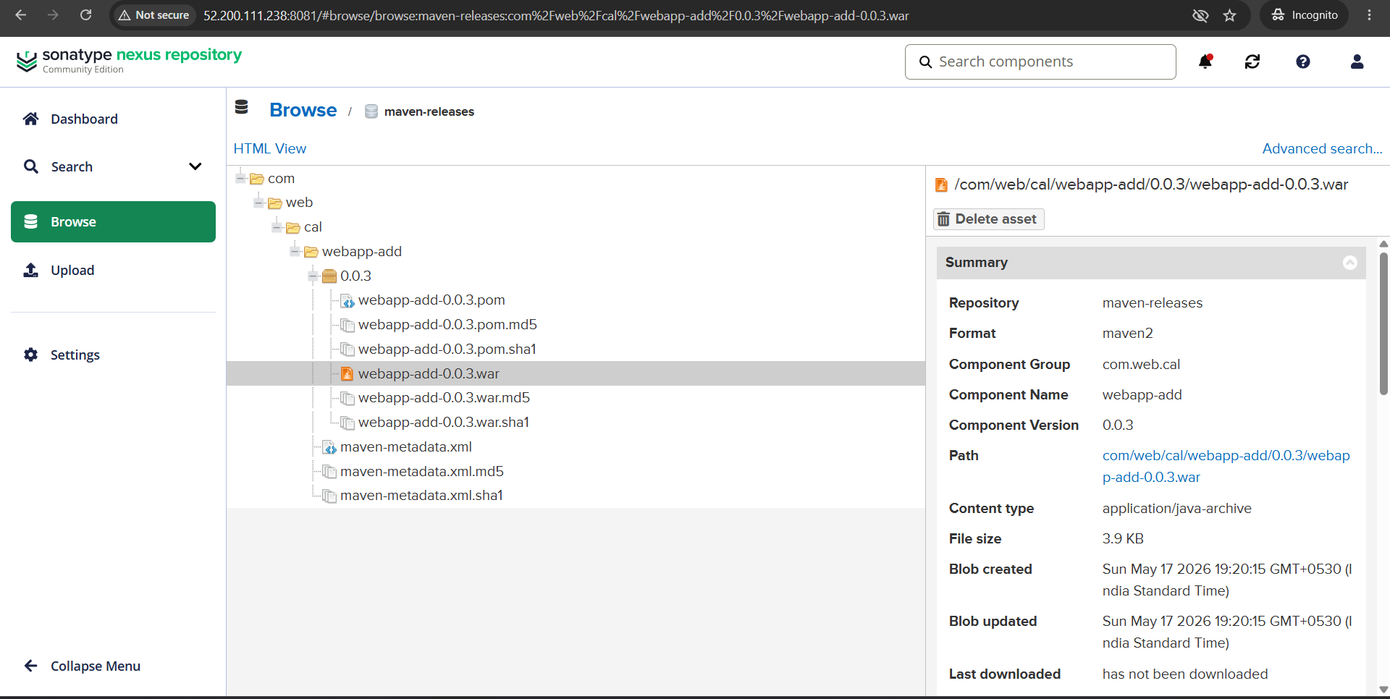
- WAR artifact uploaded successfully

Step-5: Deploy Server Setup (Deploy-VM)
- Launch Ec2 instance on AWS
- Name instance as Deploy-VM
- Select ubuntu AMI
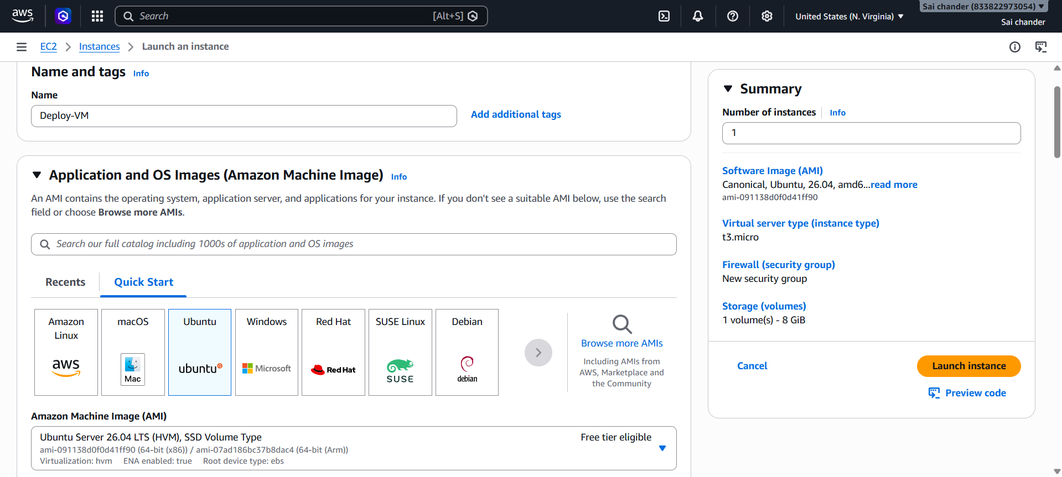
- Select Instance type t3.micro with 2vCPU and 1GB memory, keypair
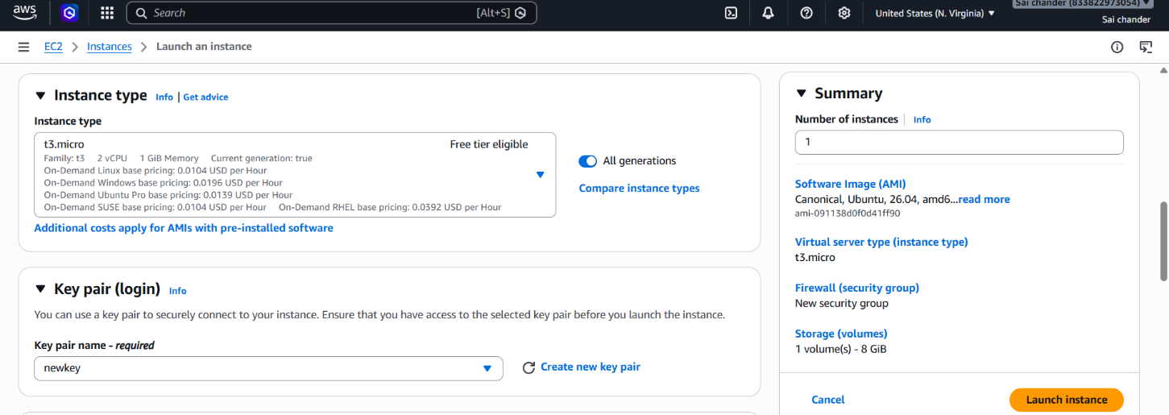

- Security Group rules - SSH port 22 and port 8080(Tomcat)
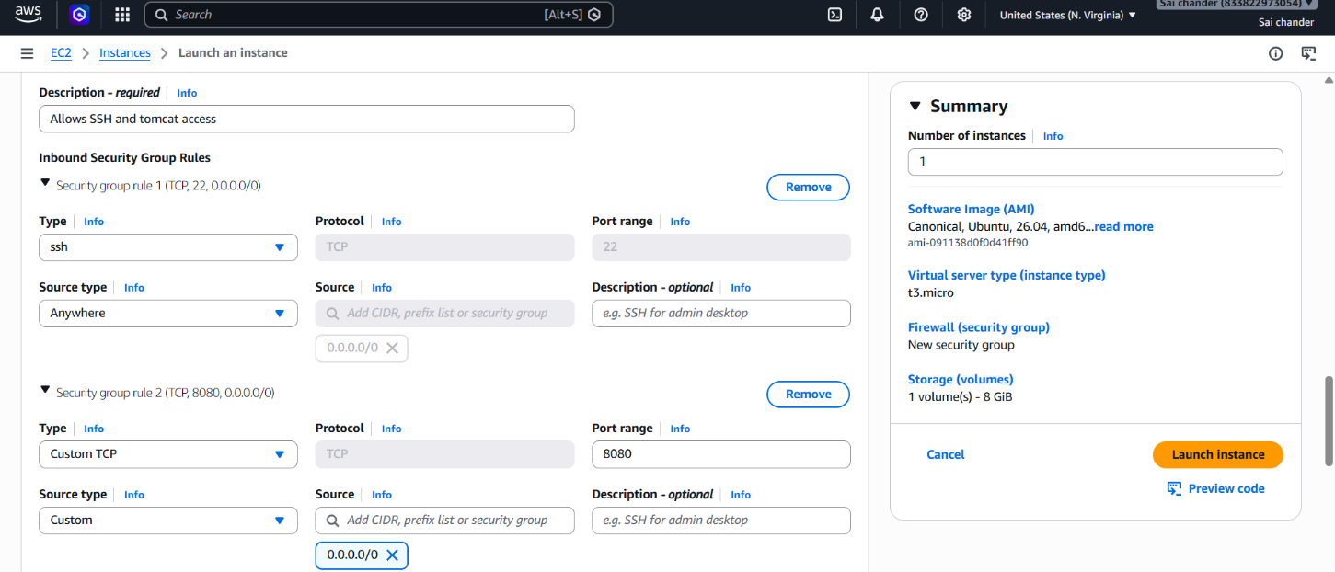
- Launch Instance
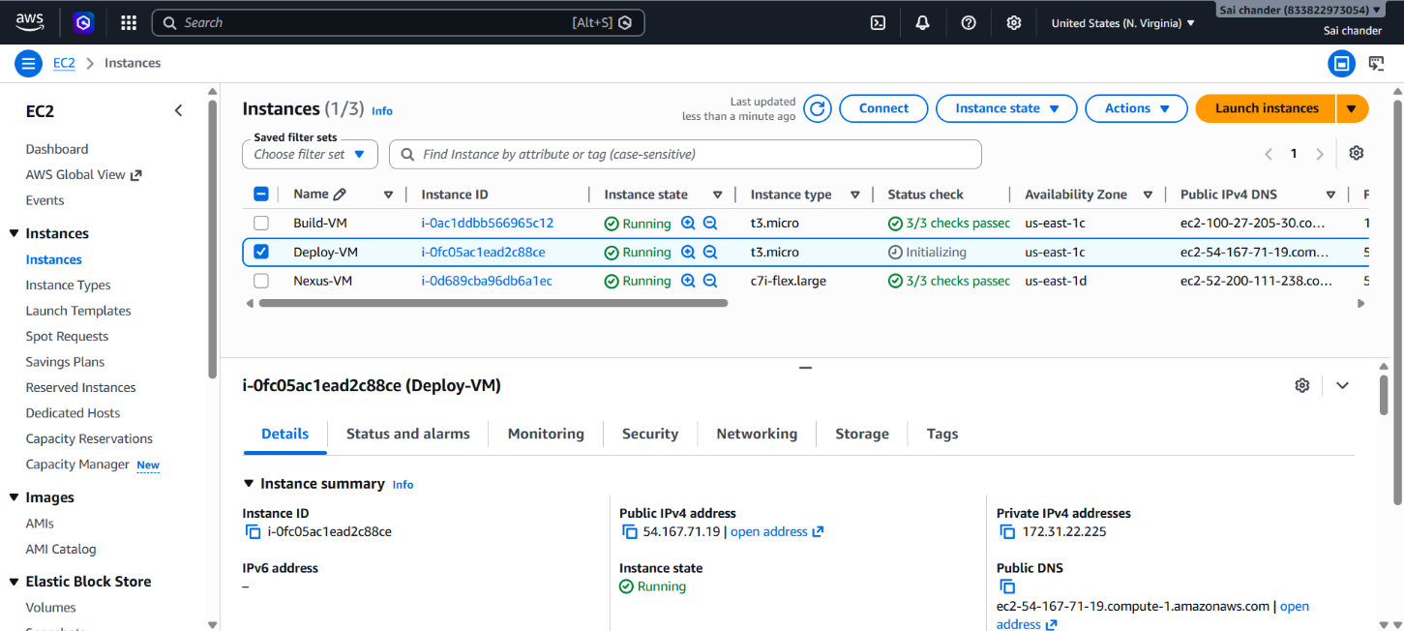
- Instance Running and connected to terminal via SSH client
- Install Java 17
- check java version
- Download Tomcat
Wget https://dlcdn.apache.org/tomcat/tomcat-9/v9.0.118/bin/apache-tomcat-9.0.118.tar.gz

- Extract Tomcat
tar -xvzf apache-tomcat-9.0.118.tar.gz
- Start Tomcat
./startup.sh
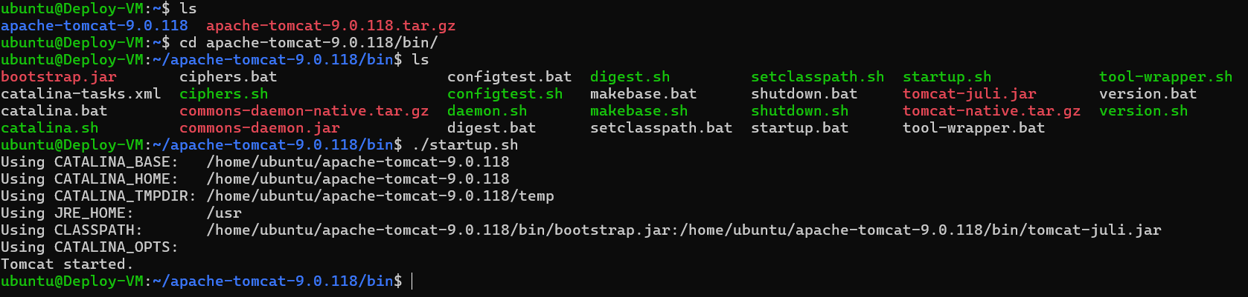
- Tomcat Started, verify in browser
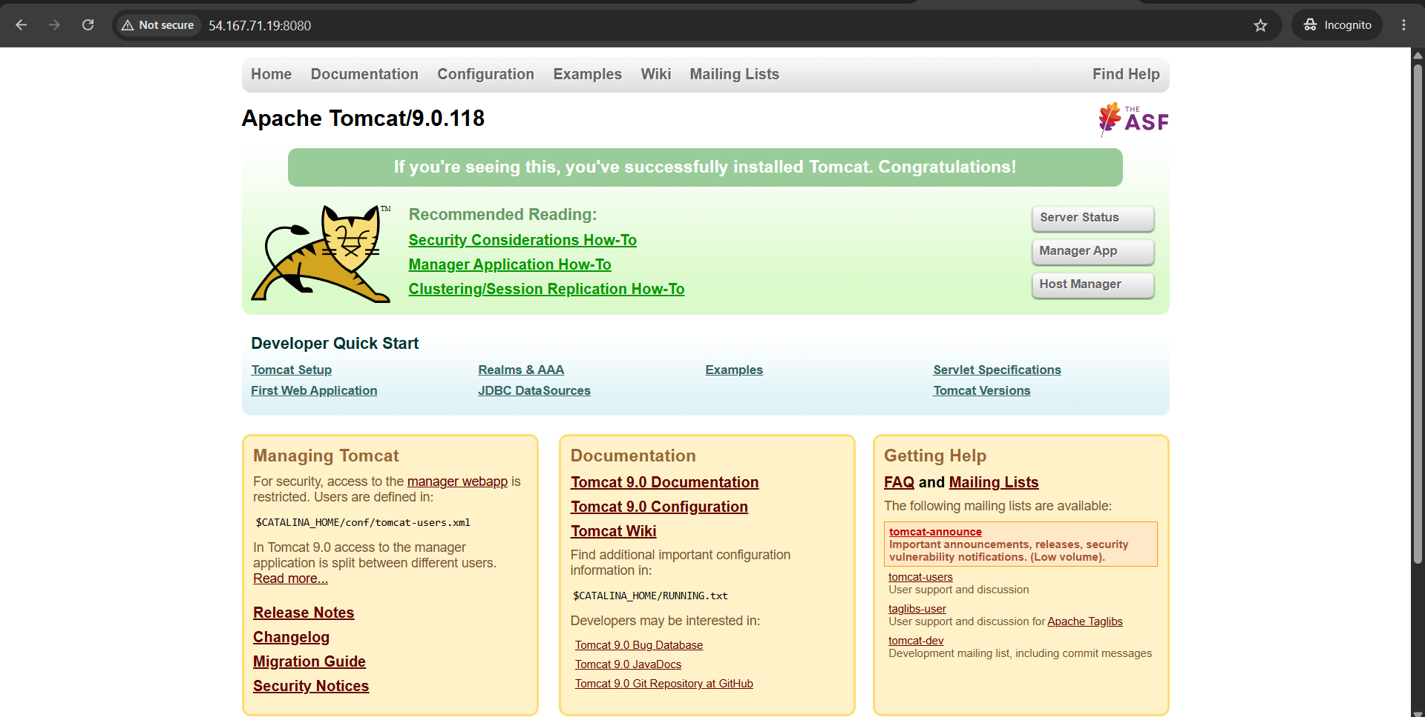
- Tomcat Running
- Add credentials in tomcat-users.xml under <tomcat-users>

- Download Artifact in Webapps using Artifact path in Nexus repository
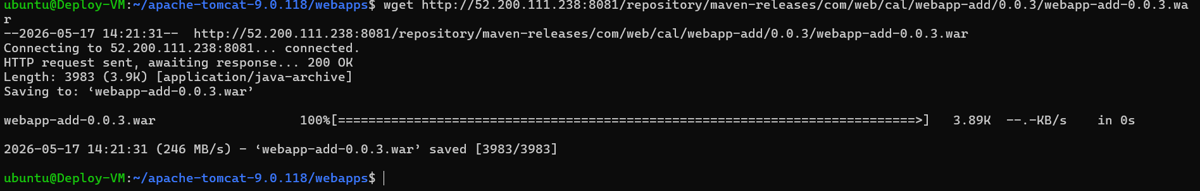
- Artifact Downloaded
- Refresh and run artifact file in tomcat on browser
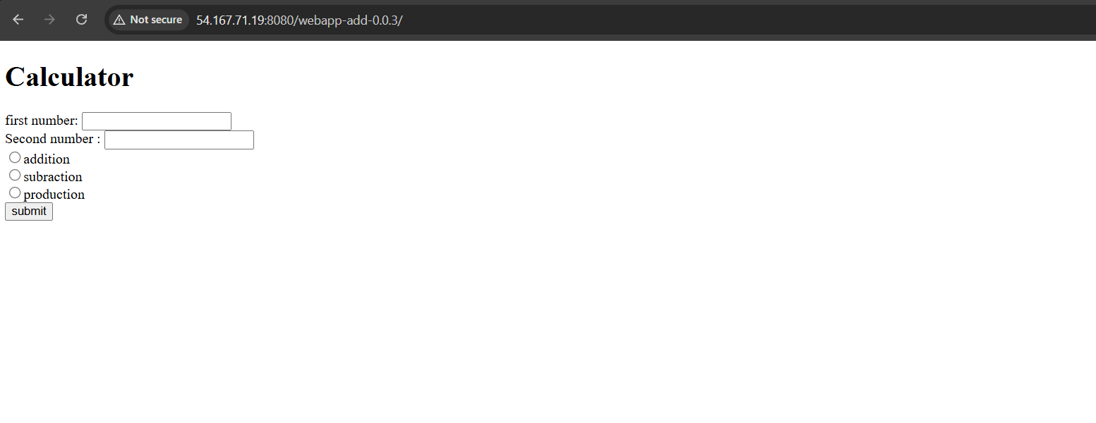
- Java Application is deployed and running

The application context path generally matches the WAR filename without the .war extension. The application was then tested by performing a calculator operation to confirm that deployment was not only reachable but also functional.
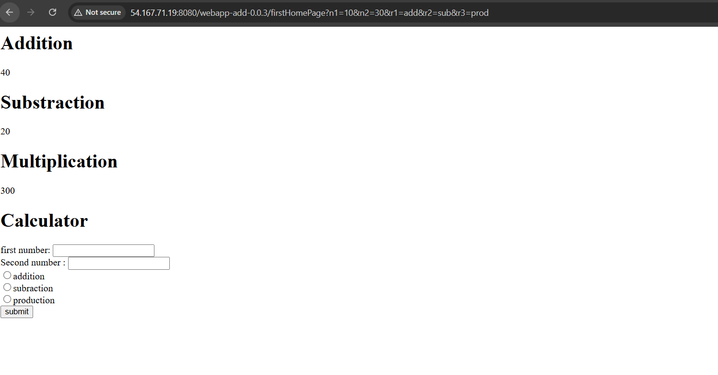
Output
The final output of this Task was a working multi-server pipeline in which the Java Web Calculator application was cloned and built on the Build Server, stored in Nexus as a WAR artifact and then downloaded and deployed on Apache Tomcat running on the Deploy Server. This completed the required flow of build, artifact storage and deployment using three separate virtual machines

